[Title page here]

Contents

Introduction

Features

Instructions

Interface

1. Main Interface (No file selected or added).

Add File

Encryption/Decryption Settings

Encrypt File

Decrypt File

Remove File

Delete File

Edit File

Open File Location

# Introduction

Who wants to prevent their files from being opened by unwanted individuals? Crypty Chops is a file encryption program. It includes multiple encryption algorithms and will safely keep your files from prying eyes.

This document will show you how to use the functions of this program.

## Features

* Safely encrypts and decrypts files.
* Stores a list of files for quick encryption and decryption
* Online help
* Beautifully crafted icons

# Instructions

## Interface

### 1. Main Interface (No file selected or added).

This is how the interface would look the first time you run Crypty Chops. From the main screen you can initiate all functions such as Encryption. (Once a file has been added).

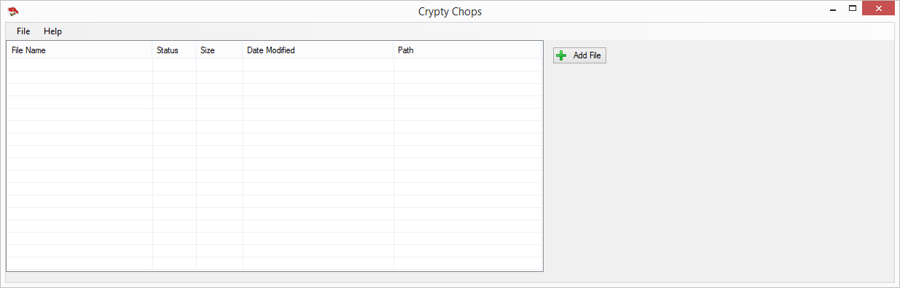

## Add File

*Add a file* to the list. You can then encrypt or decrypt it.

1. Click the **Add File** button.  
     
   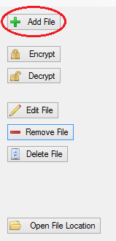
2. This will open the file browser dialogue. Browse to your file to add it to the list. 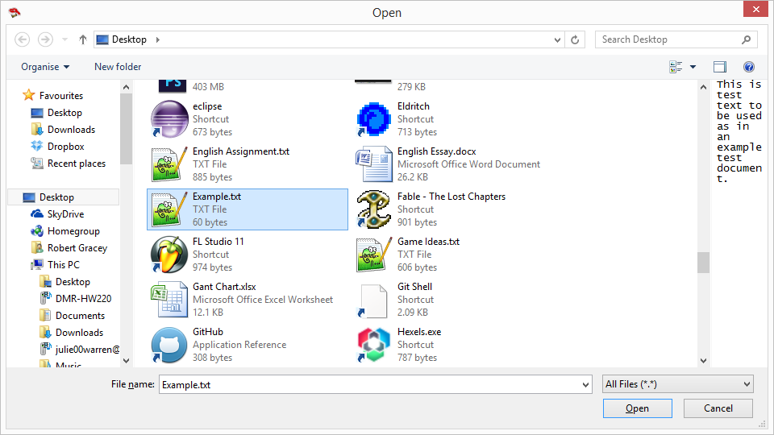

The file will now appear in the list.

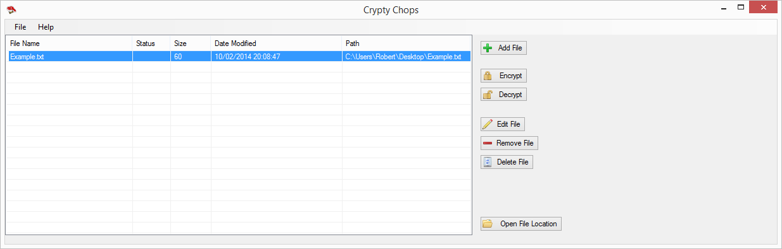

## 

## Encryption/Decryption Settings

[ Encryption / Decryption panel ]

## Encrypt File

Encrypt a file that is in the list.

1. *Select a file* from the list to encrypt, then click the **Encrypt** button. (You need to Add a file before you can encrypt it).  
   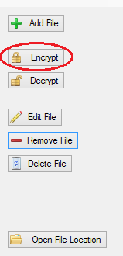
2. Enter the details for encryption. See Encryption/Decryption Options.  
   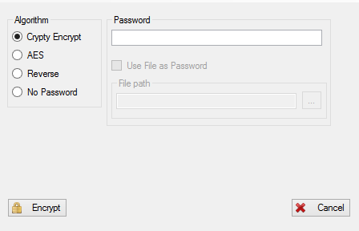
3. Press the **Encrypt** button to encrypt your file
4. The file will be encrypted with the selected settings.

## 

## Decrypt File

Decrypt a file that is in the list.

1. Select a file from the list to decrypt, then click the **Decrypt** button. You need to a file to the list before you can decrypt it.  
   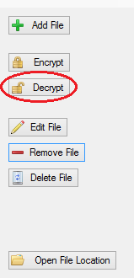
2. Enter the details for decryption. See Encryption/Decryption Options.  
   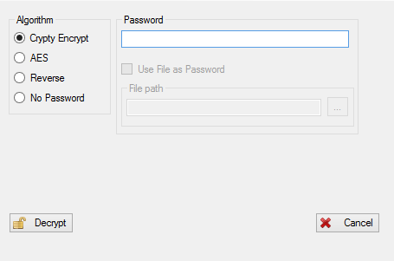
3. Click the **Decrypt** Button.  
   The file will now be *decrypted* with the options provided.  
   If the *password* is incorrect the file will not be decrypted.  
   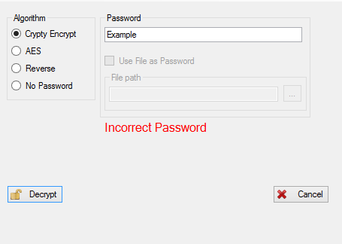

## 

## Remove File

Remove a file from the list. This will not Delete the file from the disk.

1. Select a file from the list
2. Click the **Remove File** button.  
   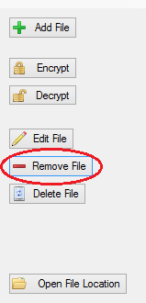

## 

## Delete File

Delete the file from the disk. Permanently. This will also remove the file from the list.

1. *Select a file* from the list.
2. Click the **Delete File** button  
   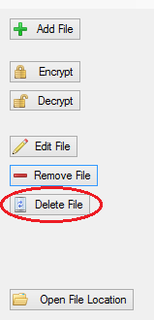

## Edit File

In some cases you might want to change the path of a file that is in the list.

1. *Select a file* from the list
2. Click the **Edit File** button  
   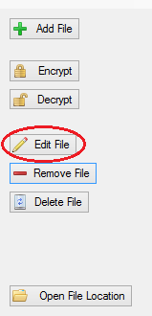
3. Change the *path* of the file
4. Click the **Save** button

## 

## 

## 

## 

## 

## 

## 

## 

## 

## Open File Location

Open the folder in which the file is located.

1. Select a file from the list.
2. Click the **Open File Location** button.  
   